ps -ef | grep Jenkins
is used to check whether the Jenkins process is running on a Linux system.
(it is used to find Jenkins port number )
The default Jenkins port number is 8080.
The command:
ps -ef
is used to display all the currently running processes on a Linux system.
Let's understand each part:
- ps = Process Status
  - It shows information about the processes (programs) currently running.
- -e = Every process
  - Displays all processes running on the system, regardless of which user started them.
- -f = Full format
  - Shows detailed information about each process.
Allow All Traffic in AWS Security Group
Step 1
Log in to your AWS Management Console.
Step 2
Go to EC2 → Instances.
Step 3
Select your Jenkins EC2 instance.
Step 4
Click the Security tab.
Step 5
Click on the Security Group attached to the instance.
Step 6
Click Edit inbound rules.
Step 7
Click Add rule (if needed).
Step 8
Configure the rule:
- Type: All Traffic
- Protocol: All
- Port Range: All
- Source: 0.0.0.0/0 (Anywhere-IPv4)
If you also need IPv6 access, add another rule with Source: ::/0 (Anywhere-IPv6).
Step 9
Click Save rules.
Step 10
Copy the Public IPv4 Address of your Jenkins EC2 instance from the AWS Console.
Example:
43.204.102.182

Step 11
Open a new browser tab and enter the following URL:
http://<Public-IP>:8080
Example:
http://43.204.102.182:8080
or
43.204.102.182:8080
Then press Enter.
If Jenkins is installed and running successfully, the Unlock Jenkins page will appear.
Step 12
On the Unlock Jenkins page, copy the file path displayed under the administrator password instructions.
The path is:
/var/lib/jenkins/secrets/initialAdminPassword

Step 13
Connect to your Jenkins EC2 instance using SSH (or MobaXterm).
Run the following command to display the initial administrator password:
sudo cat /var/lib/jenkins/secrets/initialAdminPassword
Explanation:
- sudo → Runs the command with administrator (root) privileges.
- cat → Displays the contents of a file.
- /var/lib/jenkins/secrets/initialAdminPassword → The file that contains the initial Jenkins administrator password.
Example Output:
4d3b5e6c8f2a7d9e1234567890abcdef
Copy the password displayed in the terminal.
Step 14
Go back to the Unlock Jenkins page in your browser.
- Paste the copied password into the Administrator password field.
- Click Continue to proceed with the Jenkins setup.
Step 15
On the Customize Jenkins page, you will see two options:
- Install suggested plugins (Recommended)
- Select plugins to install
Choose the option you need. For beginners, it is recommended to select Install suggested plugins.
Jenkins will then begin downloading and installing the required plugins.

Step 16
After the plugin installation is complete, Jenkins will ask you to create the first administrator user.
Fill in the required details:
- Username
- Password
- Confirm Password
- Full Name
- Email Address
Click Save and Continue.
Next, Jenkins will ask for the Jenkins URL.
- If you have purchased a domain name, enter your domain URL.
- Otherwise, keep the default URL provided by Jenkins.
Click Save and Finish.
Finally, click Start using Jenkins.

Step 17
The Jenkins Dashboard (Home Page) will open.
Step 18: Create Your First Jenkins Pipeline
- Open the Jenkins Dashboard.
- Click New Item.
- Enter the pipeline name:
test_pipeline
- Select Pipeline.
- Click OK.
- (Optional) In the Description field, type any description.
Example:
This is my first Jenkins pipeline.
- Scroll down to the Pipeline section.
- Under Definition, select Pipeline script.
- Paste the following Hello World pipeline script:
pipeline {
agent any

stages {
stage('Hello World') {
steps {
echo 'Hello, Jenkins!'
}
}
}
}
- Click Save.
- Click Build Now from the left-hand menu.
- Click on the latest Build (for example, #1) and then click Console Output to see the result.
Expected Console Output
Started by user admin

[Pipeline] Start of Pipeline
[Pipeline] stage
[Pipeline] { (Hello World)
Hello, Jenkins!
[Pipeline] }
[Pipeline] End of Pipeline

Finished: SUCCESS

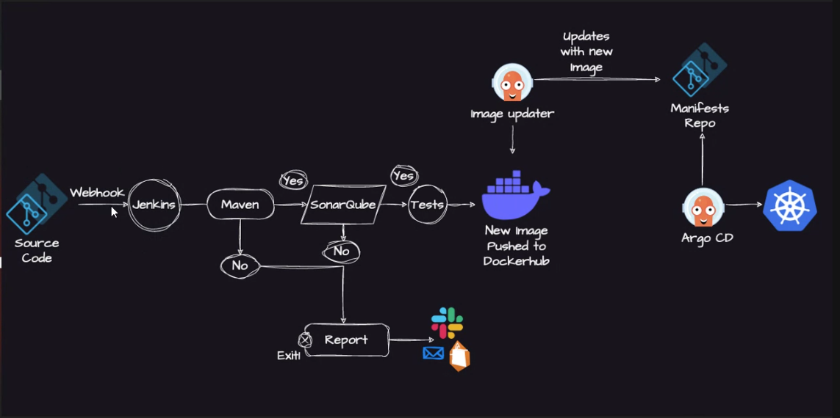
his diagram shows a complete CI/CD pipeline using Jenkins, Maven, SonarQube, Docker, Docker Hub, Argo CD, and Kubernetes.
I'll explain it step by step.

Step 1: Developer Pushes Source Code
A developer writes code and pushes it to a Git repository (GitHub, GitLab, or Bitbucket).
Developer
│
▼
Git Repository

Step 2: Webhook Triggers Jenkins
A Webhook automatically notifies Jenkins whenever new code is pushed.
Without a webhook:
- Developer pushes code.
- Jenkins waits until someone manually starts a build.
With a webhook:
- Developer pushes code.
- Git immediately tells Jenkins to start the pipeline.
Git Repository
│
Webhook
│
▼
Jenkins

Step 3: Jenkins Starts the Pipeline
Jenkins is the automation server.
It performs tasks such as:
- Downloading the latest code
- Building the application
- Running tests
- Creating Docker images
- Deploying the application
Git
│
▼
Jenkins

Step 4: Maven Builds the Project
Jenkins calls Maven.
Maven performs:
- Download dependencies
- Compile the source code
- Package the application
- Generate a JAR/WAR file
Jenkins
│
▼
Maven
If Maven Build Fails (No)
If Maven cannot build the project because of compilation errors or missing dependencies:
Maven
│
No
│
▼
Report
The pipeline stops and a failure notification is sent.

Step 5: SonarQube Code Analysis
If the Maven build succeeds:
Maven
│
Yes
│
▼
SonarQube
SonarQube checks the code quality.
It looks for:
- Bugs
- Code smells
- Security vulnerabilities
- Duplicate code
- Low code coverage

If SonarQube Quality Gate Fails
SonarQube
│
No
│
▼
Report
The pipeline stops and Jenkins reports the failure.

Step 6: Run Tests
If the SonarQube Quality Gate passes:
SonarQube
│
Yes
│
▼
Tests
Jenkins executes:
- Unit Tests
- Integration Tests
- Other automated tests

If Tests Pass
Tests
│
Yes
│
▼
Docker

Step 7: Build Docker Image
Jenkins creates a Docker image.
Example:
myapp:v1
or
myapp:15

Step 8: Push Image to Docker Hub
The Docker image is uploaded to Docker Hub.
Docker Image
│
▼
Docker Hub
Now the image is available for deployment.

Step 9: Image Updater Updates the Manifest
An Image Updater watches Docker Hub.
When a new Docker image appears:
Docker Hub
│
▼
Image Updater
It automatically updates the Kubernetes manifest with the new image version.
Example:
Before:
image: myapp:v1
After:
image: myapp:v2
The updated manifest is committed to the Manifest Repository.

Step 10: Manifest Repository
This Git repository stores Kubernetes YAML files.
Example:
deployment.yaml
service.yaml
ingress.yaml
After the image update:
Manifest Repository
contains the latest Docker image tag.

Step 11: Argo CD
Argo CD continuously monitors the Manifest Repository.
Manifest Repo
│
▼
Argo CD
When it detects a change, it automatically synchronizes the Kubernetes cluster.

Step 12: Kubernetes Deployment
Argo CD deploys the latest application into Kubernetes.
Argo CD
│
▼
Kubernetes Cluster
The application is now running with the newest Docker image.

Failure Flow
If any stage fails:
- Maven Build ❌
- SonarQube Quality Gate ❌
- Tests ❌
the pipeline stops.
Failure
│
▼
Report
A report or notification is sent (for example, to Slack or email) so the development team can fix the issue before deployment.

Complete Pipeline Flow
Developer
│
▼
Git Repository
│
Webhook
▼
Jenkins
│
▼
Maven (Build)
│
├── No ──► Report ► Exit
│
Yes
▼
SonarQube
│
├── No ──► Report ► Exit
│
Yes
▼
Tests
│
├── No ──► Report ► Exit
│
Yes
▼
Build Docker Image
│
▼
Push to Docker Hub
│
▼
Image Updater
│
▼
Manifest Repository
│
▼
Argo CD
│
▼
Kubernetes Cluster
Interview Explanation
In this CI/CD pipeline, a developer pushes code to a Git repository. A webhook automatically triggers Jenkins. Jenkins uses Maven to build the application. If the build succeeds, SonarQube performs static code analysis. If the code passes the quality gate, automated tests are executed. After successful tests, Jenkins builds a Docker image and pushes it to Docker Hub. An image updater updates the Kubernetes manifest repository with the new image version. Argo CD detects the manifest change and automatically deploys the updated application to the Kubernetes cluster. If any stage fails, the pipeline stops and a report or notification is generated.

